**SET**

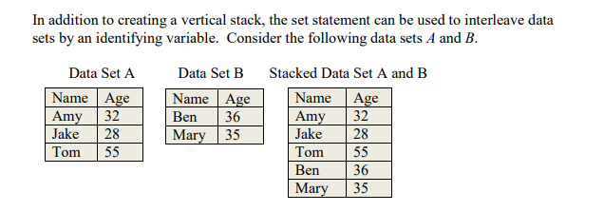

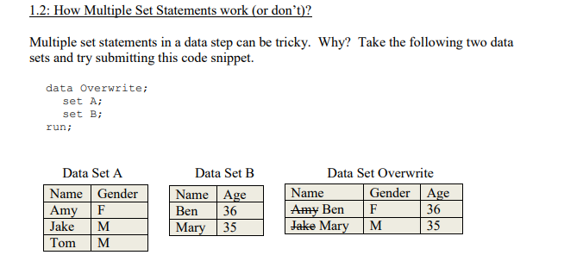

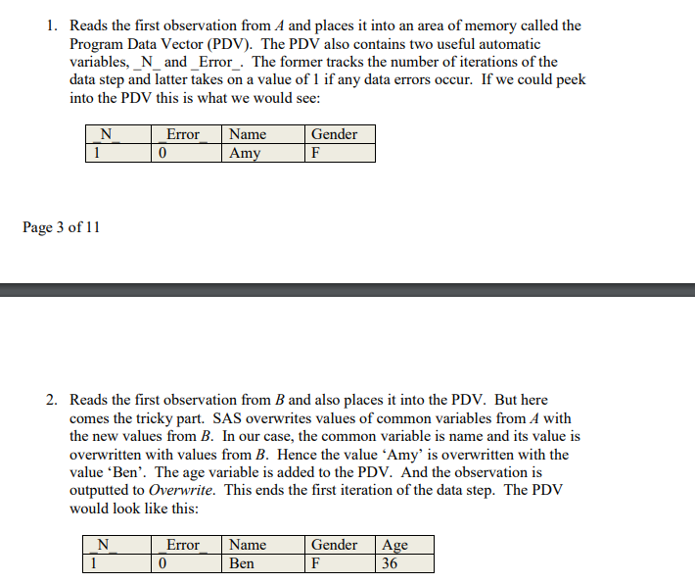

<https://www.lexjansen.com/pnwsug/2009/Gehring,%20Renu%20-%20Multiple%20Set%20Statements%20in%20a%20Data%20Step.pdf>